**Evidence for Implementation and Testing Unit**

Rachael Ellen, Cohort E20

**I.T 1- Demonstrate one example of encapsulation that you have written in a program.**

The example below shows Instruments.java with private access to name, boughtPrice, sellPrice and instrumentType. This means that only the Instrument Class (and any other classes which inherit from it) can access those attributes within methods within the class, such as getName (line 28 on Instruments Screenshot). However, that method (getName), is public, which means it can be accessed outside of Instruments class, for example, in Shop.java where it is called on Line 11. This is an example of encapsulation as the private attributes for Instrument as encapsulated only within the Instruments.java class and are not available outside.

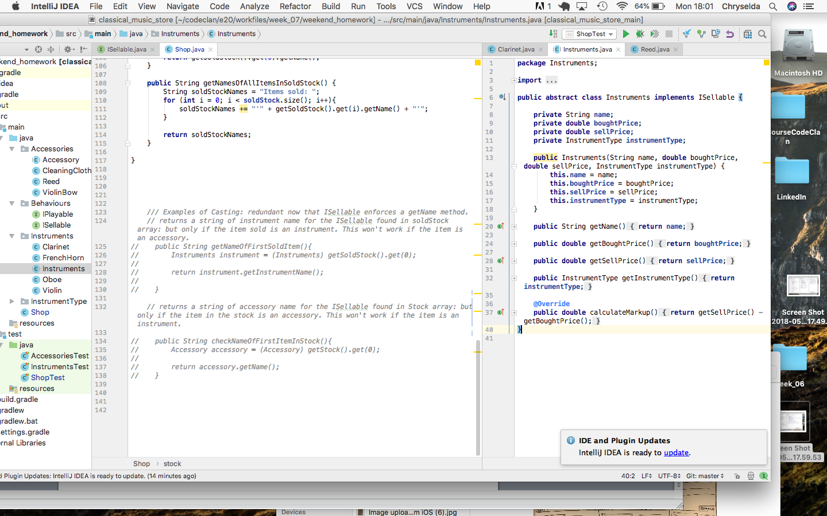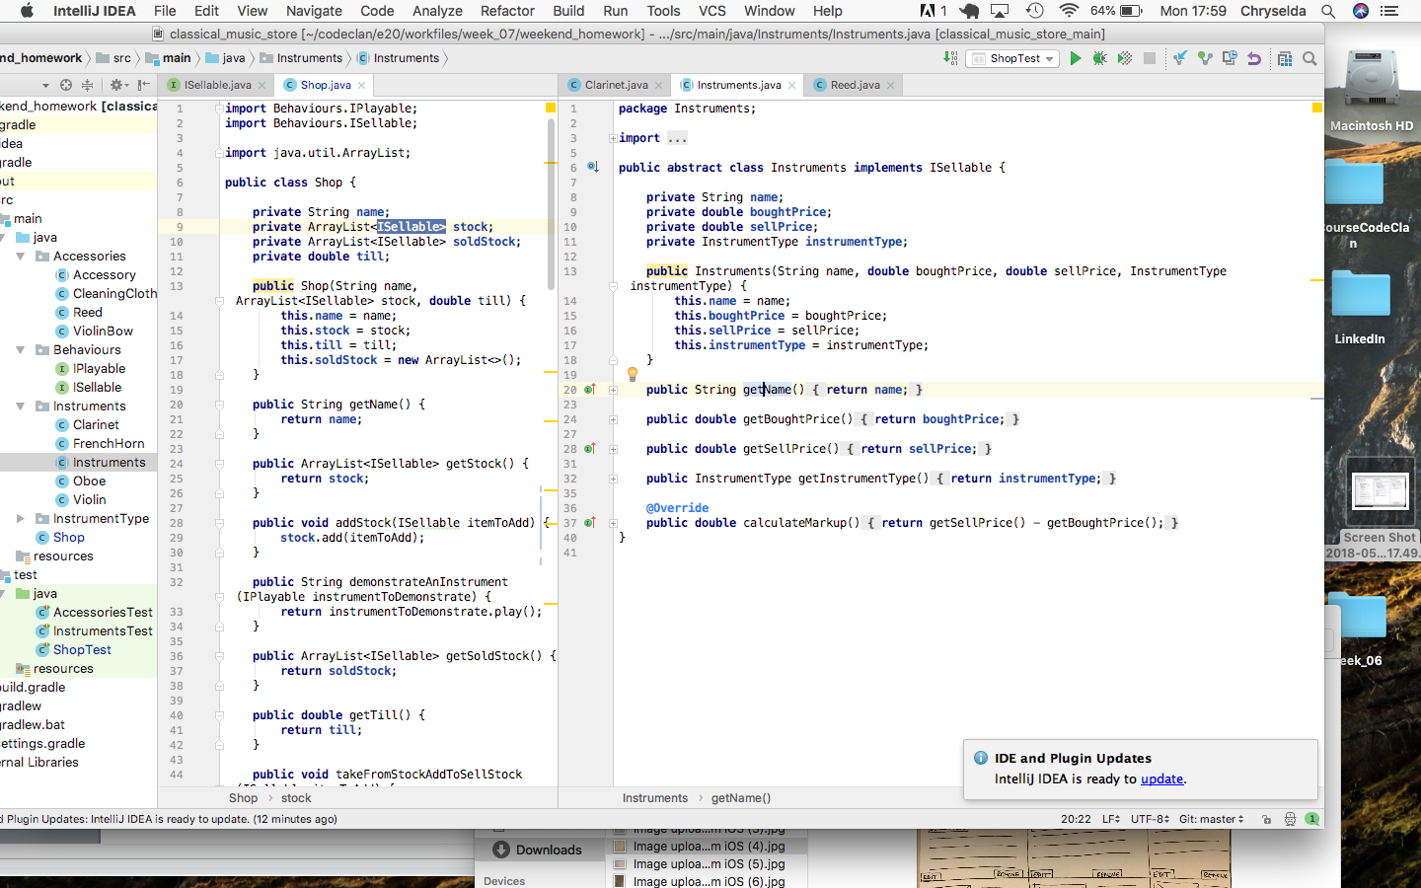

**I.T 2 - Example the use of inheritance in a program.**

*Reed.java inherits from Accessory.java*

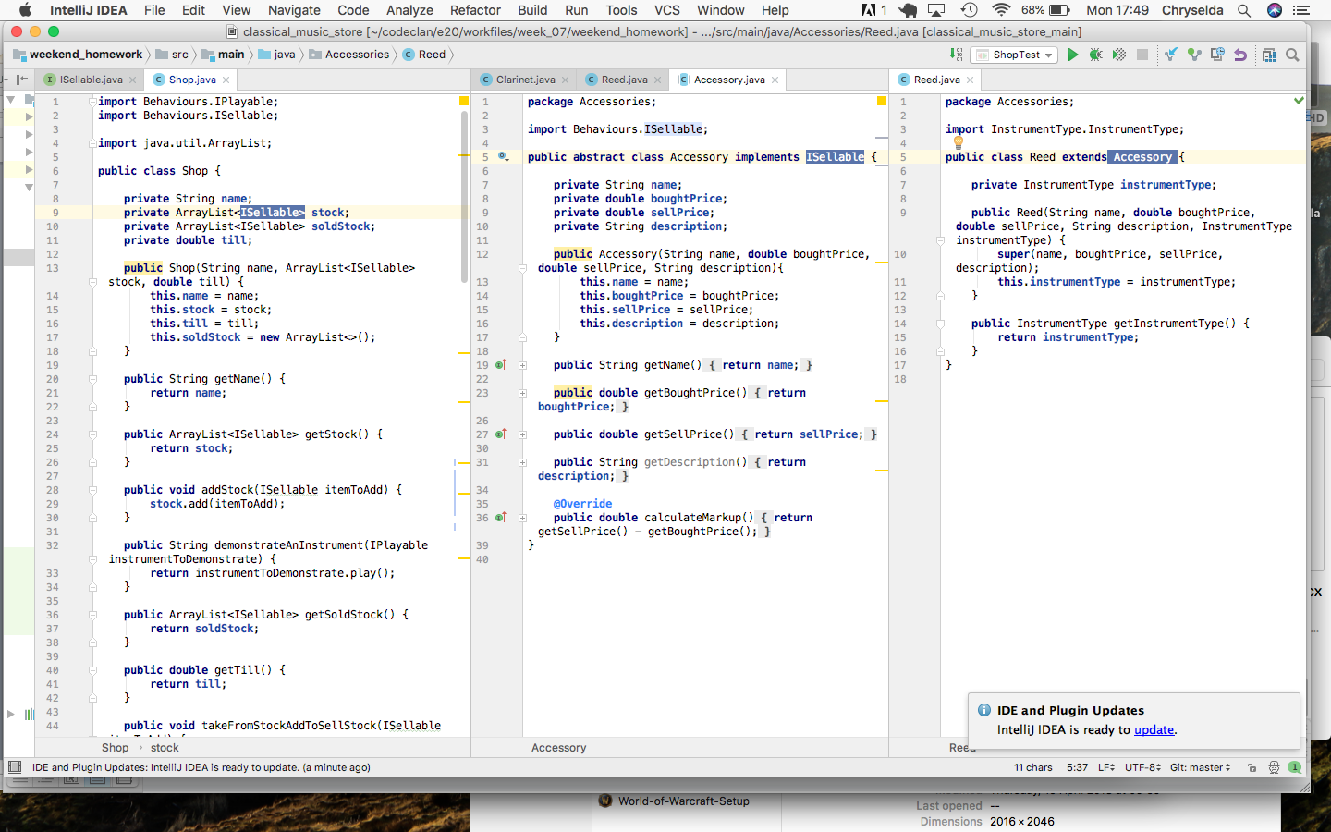

**I.T 3 - Example of searching**

(if you do not have a search and sort algorithm, write one up, take a screenshot. Remember to include the results as well.)

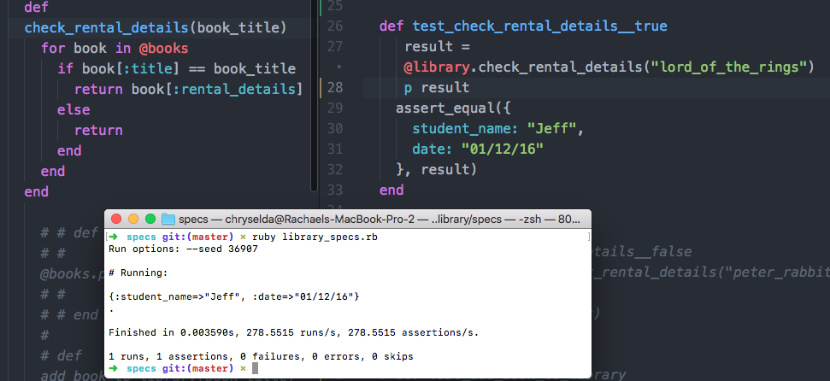

**I.T 4 – Example of sorting**

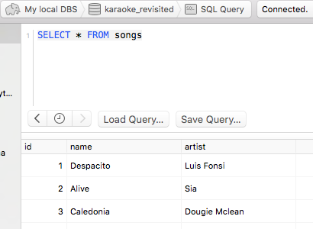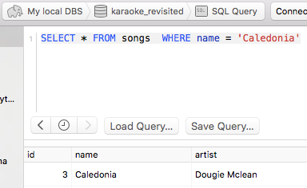

**I.T 5 - Example of an array, a function that uses an array and the result**

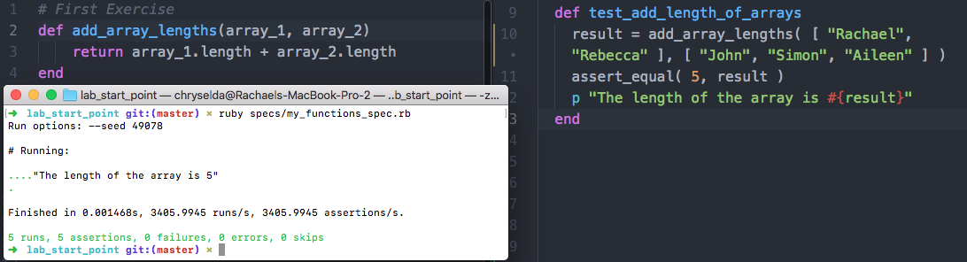

**I.T 6 - Example of a hash, a function that uses a hash and the result**

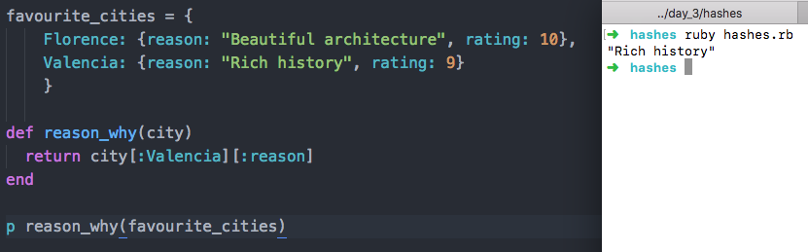

**I.T 7 - Example of polymorphism in a program**

*Accessory is also an ISellable: example of polymorphism*

